Shabbos Stories for
Parshas bamidbar 5775
Volume 6, Issue 36 5 Sivan 5775/ May 23, 2015
Printed L’illuy nishmas Nechama bas R’ Noach, a”h

For a free subscription, please forward your request to keren18@juno.com

The Pearl from G-d
Ruth Rabbah 3:4; Exodus Rabbah 52:3

Rabbi Chiya and Rabbi Shimon ben Chalafta were learning Torah together in the great study hall in Tiberias on the afternoon before Passover (according to some, it was the afternoon before Yom Kippur) when they heard people talking loudly.
Rabbi Shimon asked Rabbi Chiya, “What are they doing?”
Rabbi Chiya said, “Those who have are buying groceries, and those who have nothing are going to their employers to demand their pay.”
Rabbi Shimon said, “If that’s what’s going on, I’m going to go to my employer and He’ll pay me, too.”
He left the city and went to pray in a cave near Tiberias. Soon he saw a hand stretch out and offer him a valuable pearl. He brought the pearl to RabbiYehuda Hanasi, who asked him, “Where did you get this? It looks priceless! Take these three dinars, buy all you need in honor of the holiday, and after the holiday, we will spread the word and see what price it fetches.”
Rabbi Shimon took the three dinars, went shopping, and went home. His wife saw what he’d bought and asked, “Shimon, have you become a thief? Where did you get this?”
“It’s from G-d,” he said.
“If you don’t tell me where you got it, I won’t taste even a bite of it,” his wife said.
“I prayed to G-d, and He gave it to me,” he said.
“In the world to come, all the righteous ones will be sitting under canopies that are laden with jewels. Are you telling me that you won’t mind if your canopy has a pearl missing?”
“What should I do?” he asked.
“Go return all the things you’ve bought, give the money back to whoever loaned it to you, and return the pearl to its owner.”
When Rabbi Yehuda Hanasi heard that Rabbi Shimon had changed his mind about accepting the pearl, he summoned Rabbi Shimon’s wife and told her, “You’re causing your righteous husband a lot of anguish!”
She asked him, “Do you want his canopy to have a pearl less than yours in the world to come?”
“And if his is lacking, do you think that there’s no righteous person who will be able to give him one?” countered Rabbi Yehuda.
“Rabbi, I don’t know if we’ll get to see you in the world to come. Doesn’t each righteous person have his own abode there?” she asked.
Rabbi Yehuda admitted that she was right.
When Rabbi Shimon heard the outcome of the conversation, he returned the pearl. When he’d taken the pearl, Rabbi Shimon’s palm had faced up; when he reached out to return it, his palm was down, the angel’s hand was under it, as if he were giving a loan to G-d.
The rabbis said, “The second miracle was greater than the first, since it’s the way of the heavens to give but not to take.”

Reprinted from last week’s email of Chabad.Org Magazine.

Joke of the Week

Sarah was always late to work. She just couldn't wake up on time. Her boss told her she would fire her if it did not stop. Sarah decided to seek the advice of her doctor. He prescribed some medication and told her to take one pill before going to sleep. She did so, and woke up before the alarm clock sounded. Feeling well rested, she headed to work. Sarah told her boss about the prescription and how well it worked. Her boss replied, “That's great, but where were you yesterday?”

Reprinted from last week’s email of Chabad of Great Neck, NY.

A Tale to Remember

The Sad Plight of the Kohein Who Divorced His Wife

A couple [in Eretz Yisroel] that had been married for fifteen years without being blessed by children, decided that the best thing for them to do was to divorce, despite their harmonious marriage. Shortly afterward, the woman discovered that she was expecting a child. The joyous news had a very sad side, as the husband was a Kohein and was forbidden to remarry his wife.
Their pain and heartbreak knew no bounds. The husband described his painful situation to Rav Chaim Kanievesky [who lived in Bnei Brak] , who told him that he couldn't see any way that he could remarry, but suggested that the man consult with his father in-law, HaGaon Rav Yosef Shalom Elyashiv [who lived in Yerushalayim].
The man went to Rav Elyashiv and repeated his tale. Rav Elyashiv told him with great pain that it's definitely forbidden for a Kohein to remarry his former wife, but advised him to go to the Kosel HaMaaravi, and daven to Hashem that He should save him.
The Kohein regarded Rav Elyashiv's words as a direct instruction, and immediately went straight to the Kosel. He approached the stones and poured out his heart without restraint. After davening for a lengthy period of time, the Kohein felt a hand on his back. He turned around and saw a righteous looking Talmid Chacham, who inquired what had happened to him.
The Kohein repeated his story, and the stranger asked him, “Do you have a father?” The Kohein didn't understand the point of the question, but he answered that of course he had a father. His father was very old and was living in a nursing home in America, and could barely communicate with those around him.
The man told him, “In my opinion, you should fly to America, and tell your father what has happened to you,” and the man then turned to leave. The Kohein wanted to explain that his father hadn’t communicated in years, but the man was instantly lost in the crowd.
The Kohein reasoned that if Rav Elyashiv told him to go to the Kosel to daven, and if this stranger approached him while he was davening and advised him to fly to America, maybe it was worthwhile for him to go to America. He decided to heed this man's words. He arranged a flight, and a day and half later he was at his father's side, in the nursing home.
The medical staff had informed the son when he first arrived that his father still does not utter any words, and that he shouldn't expect his father to speak to him.
The Kohein began telling his father the story, and his father didn't respond, but seemed to be listening to what his son was saying. As the son continued his story, he began crying uncontrollably.
Then, unbelievably, his father began speaking and said clearly, “You are not my biological son, but you were adopted after the Holocaust. You do not have the status of a Kohein, and there is no reason that you couldn't remarry your former wife!” (adapted from the sefer Barchi Nafshi)

Reprinted from the Parshas Behar-Bechukosai edition of “Torah U’Tefilah: A Collection of Inspiring Insights” compiled by Rabbi Yehuda Winzelberg.

King David and the Insects

The Midrash relates the following story:
Once, before he became king, David was sitting in the garden watching a wasp paralyze a spider. Amazed by the scene, David, who was in constant dialogue with G-d, asked Him why He created these useless creatures. The wasp doesn’t produce honey, but can dispose of bees, and the spider weaves day and night, but it cannot weave a garment. G-d’s reply was: “A day will come, and you shall learn to appreciate those creatures.”
Eventually, King Saul began to envy David’s military success and wanted to arrest him, for he feared he was a threat to his kingship. David escaped to Judah’s land and hid in a cave. A spider found the cave entrance and weaved a web in it. Saul arrived at the entrance, but saw the web and thought, “If a person would enter the cave, he would probably tear the web.”
After King Saul left, David thanked the spider.
In the next biblical episode, David went to the camp of King Saul in the desert to show him that his defenses could be cracked, but David would not harm him. David approached the king’s side to take his water canteen, but the king’s army minster moved his heavy feet onto David, thus preventing him from leaving the tent. A wasp then appeared and stung the minister so he moved his foot, and David was rescued. David thanked the wasp in his heart, turned to G-d, and said: “I understand.”
A wise man once said, “An error doesn't become a mistake until you refuse to correct it.”
A young chemist had been working for some time at developing a new bonding agent, a glue. After years, the work was complete. He tried it out. It did not stick. What use is glue that does not stick? Many would have called this a failure. This chemist thought otherwise.
Instead of deciding his work was a failure, he asked, “What if it is a success? What if I have discovered a solution? The only thing left to do is find the problem.”
He refused to give up. He kept asking himself, “What is the use of an underachieving adhesive?” Eventually he found it. It became a huge commercial success. They're little and they stick but not too much. This is how Post-It Notes were invented!
Sometimes struggles are exactly what we need in our lives. If G-d allowed us to go through our lives without any obstacles, it would cripple us. We would not be as strong as what we could have been. We could never fly!

Reprinted from last week’s email of Chabad of Great Neck, NY.

The Hidden Jews
Of Montana?
By Sara Yoheved Rigler

Sarah McConnell and the Indestructible Power of the Jewish Spark.

Sarah McConnell was born in Missoula, Montana, in 1972. Her father’s family, proud descendants of the Ulster Scots, were avid genealogists. They traced their family tree back to the Revolutionary War and a Lieutenant McConnell, who fought under General George Washington. With her sterling credentials, Sarah was accepted into the select Daughters of the American Revolution.
Her mother’s family was much harder to trace. Sophie, the great-great-grandmother who had come to Montana in the early 1900s, was from Europe, but throughout her life she refused to divulge her maiden name or where she had come from. Moreover, she had cut off all contact with her European relatives. Immigrating to America at the age of 20, on the boat Sophie married a man named Kasinov.
As Sarah wonders, “They never shared anything about their journey in terms of how they got to Montana or how they got out of Europe. I don't know the ports they left from, who their family was, or any details. I have always found that strange, because in the other branches of my family, we have a ton of oral history passed down through generations. People love to talk about it.”

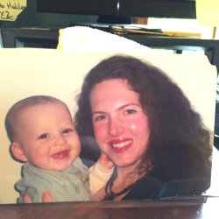
Sarah with her son

When Sarah’s mother Janet was in university, what Sarah calls, “the one Jewish man in Montana” courted her. When he asked Janet’s father for her hand in marriage, however, Sarah’s grandfather flatly refused, declaring, “No one in my family is going to marry a Jew.”
When he was 83 years old, Sarah presented him with evidence that he himself had likely married a Jew.
Unlike almost all of their neighbors, Sarah’s grandmother Lucy and great-grandmother Anna did not belong to any church. When Anna was on her deathbed, someone tried to convince her to accept Jesus. Her adamant response was: “I will NEVER accept Jesus!”
Sarah has dark, curly hair and what many would call a “Jewish nose.” Nevertheless, it’s hard to account for the repeated, uncanny instances of people labeling her a Jew.

Sarah’s father, Dr. Robert McConnell, PhD, is an academic, so the family moved several times as she was growing up. She spent her high school years in Indiana, in a town founded by German immigrants. Fellow students made fun of her, calling her “a Jew.” Recalls Sarah, “The students in the high school I attended were extremely anti-Semitic. I cannot tell you how I was bullied every day because they believed I was a Jew.”
When Sarah was a freshman in high school, she had a Jewish drama teacher who cast Sarah as one of the lead roles in the Holocaust play, I Never Saw Another Butterfly. When Sarah questioned why she had been given the part, her teacher replied, “I feel like you’re of my people.”

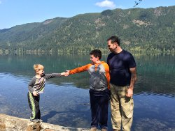
Sarah's husband and two sons

At the age of 21, Sarah went to France. Several French Algerian Muslim girls sought her out in order to improve their English. One of her Muslim friends took Sarah’s picture, and showed it to her brother. The next day she told Sarah, “My brother says you’re Jewish. He doesn’t like Jewish people.” Sarah felt maligned by her friend’s comment, but reassured her that her physical appearance must have come from an Italian great-great grandmother on her father’s side. Although her Italian relatives were actually very fair, Sarah could think of no other explanation.
After getting her Master’s Degree at University of York in England, Sarah moved to Seattle, Washington, and got a job in information technology.
She became engaged to a man named Edward. Although Sarah was always kind to Ed’s mother, she hated Sarah, accusing her of being Jewish. Eventually, Ed’s mother forced him to break the engagement.
Broken-hearted, Sarah moved to a different town in Washington and searched for a new job. A female recruiter picked up Sarah’s resume and asked her out for coffee. She told Sarah that she herself was Jewish and added, “You look like the women in Israel. Are you Jewish?”
I always felt a kinship to the Jewish People.
Sarah responded, “Thank you. That’s a wonderful compliment because I always felt a kinship to the Jewish People.”
Some time afterward, Sarah set up her profile on a dating website. She used very specific search criteria to be matched, including the word “Christian,” but no good matches came up. One day, gripped by a strong feeling, she deleted the word “Christian” and replaced it with “Jewish.” The very first profile that came up, along with 100% matching criteria, was of a Russian Jew named Vladislav.
Vladislav was doing his second year of medical residency in Olympia, Washington. Both Sarah and Vlad were 29 years old. As soon as they met in person, they felt an immediate affinity.
Vlad’s parents, although nonobservant, were adamant that he should marry only a Jew. Early on in their dating, the subject of her not being Jewish came up. Vlad would call Sarah his “Yenta.” She would reply, “Well, I don’t think that’s the case.”
He would answer with conviction, “I really feel like you are Jewish.”
She would respond, “That sounds like wishful thinking.”
Although trained as a scientist, Vlad would insist, "I don't think so. I really do feel that you are Jewish."
Succumbing to parental pressure, Vlad broke up with Sarah five times. The irony: One prospective mother-in-law rejected Sarah because she thought she was Jewish, and another rejected her because she thought she wasn’t.
Finally, they eloped to Idaho in 2003.

The Spainish Connection
A few years later, Sarah became involved again in researching her family tree. She had her father’s side in perfect detail, but her matrilineal line was still a mystery. “I was frustrated,” she recalls, “that there was nothing on my matrilineal line back in Europe.”
Sarah decided to do a DNA test on her matrilineal line. The results that came back shocked her. Her DNA put her in a cohort of almost 100 people, all of them Jews, and most of them Sephardic Jews. (Sephardic Jews are descended from Jews who chose to leave Spain in 1492 rather than convert to Christianity.)
Sarah phoned the DNA company and asked them if there was a mistake. They explained to her their strict testing protocols and their high rate of accuracy. There was no mistake, they assured her.
When Sarah informed her mother of what she had discovered, Janet responded, “Are you sure?” Sarah repeated the DNA company’s assurances. Her mother was silent for a few moments, and then said simply, “It makes sense.” Janet admitted that she had always wondered if their roots were Jewish.
The DNA results spurred Sarah to do a genealogical search of her matrilineal line. She discovered, through Ellis Island records, that her great-great grandmother, who had emigrated from Europe and had refused to divulge her maiden name, was named “Sophie Schaub.”
Sarah then researched the name “Schaub” on a Jewish genealogy database, and found “Schaub” on a registry of Jews in Spain in the late 1400s. From two directions, DNA testing and genealogy, the trail led back to the same place: the Jews of Spain.
“We come from a long line of rabbis who would rather die by the sword than convert.”
According to Jewish law, DNA testing does not determine one’s Jewishness. While Sarah’s status as a Jew has yet to be determined by rabbinical authorities, she believes she has discovered an “unbroken matrilineal line” reaching from 15th century Spain to 20th century Montana. Sarah, her husband, and two sons celebrate the Jewish holidays and are in the process of choosing a synagogue. Her journey continues.
She has made contact with many of the people who share her DNA profile. One such woman in France told her: “We come from a long line of rabbis who would rather die by the sword than convert.”
Is it possible that a spark of Jewish soul survived for five centuries, from the Spanish heroes who sacrificed everything rather than submit to the Church, through Sophie Schaub, who deliberately buried her Jewishness, yet whose daughter Anna, unaware of her heritage, on her deathbed proclaimed, “I will NEVER accept Jesus,” to a modern Midwesterner whose Jewish spark, flickering after generations of assimilation and intermarriage, still radiated a light that so many saw?

Reprinted from last week’s email of Aish.com

Jewish Cemetery Survives Within GM Auto Plant in Detroit
The Associated Press (May 12, 2015)

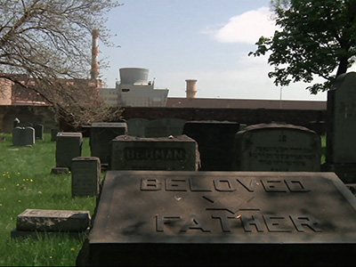

HAMTRAMCK, Mich. — Beth Olem Cemetery is like many aging, final resting places, with assorted tombstones in varying condition, sizes and styles, surrounded by a brick wall and iron gate.
Yet surrounding it on all sides is an unusual neighbor: a massive automotive plant.
The serene, green oasis is enveloped by the steel and concrete structures and grounds of General Motors Co.'s Detroit Hamtramck Plant, which makes Chevrolet Volts, Cadillacs and other cars. To maintain plant security, public access to the cemetery is limited to a couple days a year — typically Sundays nearest to the Jewish holidays of Rosh Hashanah and Passover — and some special requests. This year, the opening around Passover was postponed a month until this past Sunday, when a couple dozen people showed up.
The 2.2-acre, 1,100-grave Jewish cemetery with burials ranging from the late 1860s to the late 1940s, has survived through historical quirks. The biggest was an agreement ironed out about 35 years ago to preserve the cemetery when GM got Michigan Supreme Court approval of its contentious bid to demolish roughly 1,500 homes and businesses, several churches and a hospital so it could build a new plant.
Visitors who clear GM security and drive about a mile around the plant are welcomed by an iron arch with partly rusted letters that reads, "BETHOLEM CEMETERY."
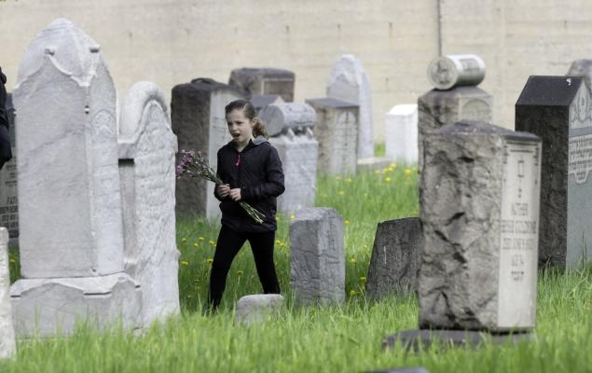
Isabelle Geller walks holding flowers at the Beth Olem Cemetery Sunday.

Given the passage of time and infrequent access, cemetery officials say visitors with no connection to the deceased outnumber descendants. Still, Sunday's guests included Susan Brodsky, who saw for the first time the grave of her great-grandfather, Chlavno Cantor, who died in 1909. The connection was made through her daughter, Olivia Brodsky, who was working on a college genealogy project, then confirmed by an elderly male cousin.

"He said it was in the Cadillac plant," said Susan Brodsky, standing next to the headstone that read "Cantor" in English and the rest in Yiddish. "At first, I'm sitting there going like, 'Where? Where? What is he talking about?' Then I started Googling 'old Jewish cemeteries in Detroit' and it was pretty obvious. ... This was it."
The cemetery's existence isn't widely known, but those searching online can find some information. Local historic and Jewish organizations as well as a weekly Jewish publication occasionally write about it, and some learned about the cemetery opening from those websites and social media.

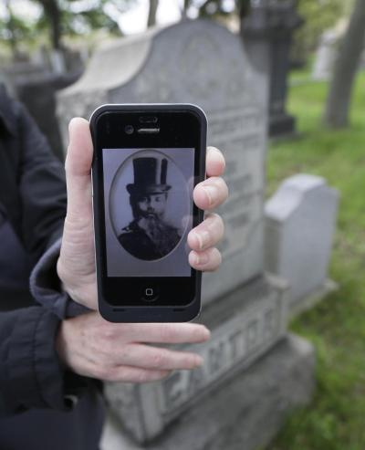
Susan Brodsky shows a photo of Chlavno Cantor, her great-grandfather, and stands next to his gravestone at the Beth Olem Cemetery. (Photo by Carlos Osorio/AP)
In the early 1860s, members of what's now called Congregation Shaarey Zedek secured the burial ground, according to a 1992 article published by the Jewish Historical Society of Michigan. Beth Olem's bucolic setting soon gained industrial neighbors as the auto industry ascended at the turn of the 20th century. The Jewish community moved in subsequent decades, and the cemetery had fewer burials as other cemeteries opened.
Ralph Zuckman is executive director of Shaarey Zedek's Clover Hill Park Cemetery, a suburban Detroit cemetery overseeing Beth Olem, which is also spelled Beth Olam and means "house of the universe." He said the synagogue shared oversight with other congregations in the 1980s but assumed full responsibility when it came time to negotiate with GM.

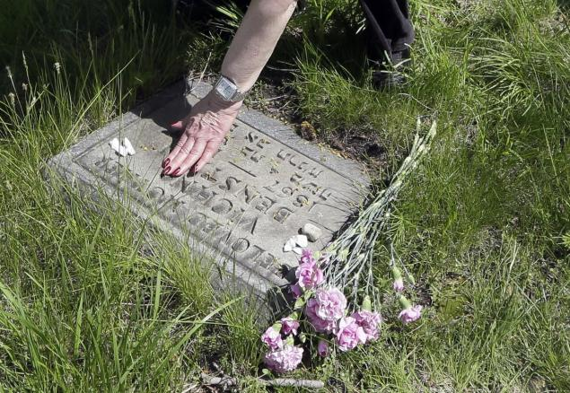
Barbara Morse touches the grave marker of her great-grandmother Vichna Benstein at the Beth Olem Cemetery. (Photo by Carlos Osorio/AP)

"We realized we had an interest in that cemetery and wanted to make sure it remained," he said. "In Hebrew, going onto a cemetery property is like walking into a synagogue. You're walking on holy ground."
While the arrangement is unconventional, Zuckman described the relationship between the automaker and cemetery officials as "very good." Some landscaping work and headstone repairs are needed, but the grounds and graves are in generally good shape given their age. Clover Hill Park is responsible and pays for upkeep, though GM has access in case of emergency.
In addition to maintaining security of the plant, GM and cemetery officials say they agreed to limit access because of low demand: Two generations have passed since the last burials and the current schedule has accommodated those who want to visit.
The gravesite of Vichna Benstein, 1867-1898, was spotted by great-granddaughter Barbara Morse, who came with her son-in-law and two grandchildren. Soon they were reciting prayers and laying flowers and stones, per Jewish custom.
Morse, 69, said she's been coming off and on for 20 years to pay respects.
"You can only come when GM says you can come, but I guess that wse should be thankful that we can come twice a year," Morse said.

Remembering Sam Zalta, A”H
By David Bibi

Some time ago I was sitting with a woman in her nineties and she was telling me about her life and how she was thankful for all her blessings. She voiced one major complaint saying that when she would eventually pass, the thought that none of her friends would be at her funeral saddened her as they had either all passed on or would probably be to infirm to attend. I learned that this is a worry that weighs on many octogenarians and nonagenarians.
On Sunday morning I attended a funeral of a man who was three weeks shy of his 101st birthday. There synagogue was filled. There was standing room only around the perimeter and there were even people up in the balcony. And it dawned on me that although this man no longer had contemporaries, every person in that Synagogue felt that they were attending the funeral of a dear friend.
Mr. Sam Zalta was my friend too. With Mr. Zalta, there was no generation gap. He connected with young and old. His deep and thunderous greeting of, “How ya doing, Pal”? will forever resonate in my ear. His signature farewell and blessing (as was common to those of his generation), Ul-lah Maak ( G-d be with you) remains with me.
Our reading this week begins by telling us of the laws of the Sabbatical Year given to Moses at the Mountain. The Rabbis ask why are we specifically told that this commandment was given at Har Sinai? One answer is that from here we learn that all the commandments in general accompanied by their specifics were given by Hashem to Moses on the mountain.
On a Homiletic level we can suggest something deeper. The highlight of history is the revelation at Sinai. At no point before or after were the people more connected with G-d. This connection is something we long for always. How can one achieve this Sinai like experience in one’s own life? Perhaps the answer lies in the Sabbatical year. Leaving one’s fields, suspending one’s pursuit of livelihood and sustenance and trusting that G-d will fulfill his promise and provide is the ultimate level of faith.
Think about what strength it takes to do that! We are all tied to corporal things and the most physical of things is land, real estate, tangible property. Perhaps Moses is telling us that to separate from that, to trust in Hashem and in nothing else lifts us to the point where we feel as we did at Mount Sinai.
This simple and complete faith is something we all saw in the earlier generations. Mr. Sam Zalta was one of our links to that generation and one saw within him this special faith binding him to Heaven. One saw it in the blessings he bestowed, in the smile he shared, in the greetings he offered and in his book of Psalms which he completed daily, each reading a strand of Mr. Zalta’s spiritual cable to the Al-mighty. His faith allowed him to remind us always and to truly believe that nothing is impossible.
I knew Mr. Zalta for my entire life. I grew up friends with his son Carlos or Charlie who remains my friend to this day. When we prayed in the youth minyan at Ahi Ezer with Rabbi Mevorach, it was Mr. Zalta who made sure we had Flying Saucers and Lala Paloozas – ice cream from Carvel. When we got a little rowdy and some of the older men would yell at us, it was Mr. Zalta who defended us. He treated all of us as his own children.
My father would tell me stories of Mr. Zalta and his dad Mr. Moussa Zalta who took upon himself the responsibility of greeting the immigrants from Syria who arrived into New York. He made it his job to show them a friendly and recognizable face and helped them find a place to stay so that no one would find themselves helpless or homeless.
The fruit never falls far from the tree.
When I began working and spent hundreds of days on the road each year, I often spoke with Mr. Zalta when calling Whiz Travel. “How ya doing pal” and
“Ul-lah Maak” began and ended the hundreds of brief conversations we had. When I was stranded somewhere because of a ticketing issues, flight cancellations, airline overbooking or simply arriving too late, rather than speak with an airline customer service desk, it was a phone call to Whiz that I knew could help.
“Don’t worry Pal, we’ll get you home, just hold on for a second while I’ll get Carlos.” His reassuring tone always helped lift some of the natural anxiety one faces when they hear, “sorry, you can’t get there from here today”. And sure enough, no matter the assurance and promise, his blessing was truly a blessing and his children always found a way to fulfill that promise and get us there from here! Thousands of you out there shared the same experience and undoubtedly the same memories.
On a more personal level, Mr. Zalta was definitely my number one newsletter fan. His children and grandchildren told me how he would read each issue four or five times, how he took the papers with him to bed and how he pressed them to find out if the new issue arrived. Often when I really didn’t want to prepare anything, it was the thought of Mr. Zalta’s disappointment that motivated me. We never write for 20,000 or even 500. We write for people and Mr. Zalta was one of those faces I could always envision as my fingers crossed the keyboard.
On Sunday we attended a funeral. Strange as it sounds, it was the happiest funeral I ever attended. It was a celebration of life and legacy. We mourn our loss of this special man. We hope in his memory to take his life lessons and incorporate them into our own lives. We hope to remember to greet all with a kind face, to love and reach out to others. We pray to remember that our faces are in the public domain and we have no right to frown, but owe the world a smile. And finally to connect to him and those of that special generation recalling Ul-lah Maak, Hashem is with us and nothing is impossible.
Mr. Zalta, thanks for reminding us that nothing is impossible, A part of me believes that you’ll figure out a way to get them to distribute copies of the newsletter in heaven, if you can and they do and you’re reading this now, please say hello to dad! Nothing is impossible.

Reprinted from last week’s email of Shabbat Shalom from Cyberspace that is edited by my good email friend David Bibi.

